
ENGLAND ATHLETICS – ANNUAL GENERAL MEETING ADDITIONAL NOTES FOR COMPLETING THE PROXY FORM

If your club / organisation is not attending the Annual General Meeting in person, you can submit a Proxy Form in advance so that your club’s/organisation’s votes can be counted.

Section of Proxy form | Additional notes
Add your name
(The authorised person for the member club or registered body / organisation. Please ensure that the club details are up to date on the England Athletics portal).

Section of Proxy form | Additional notes
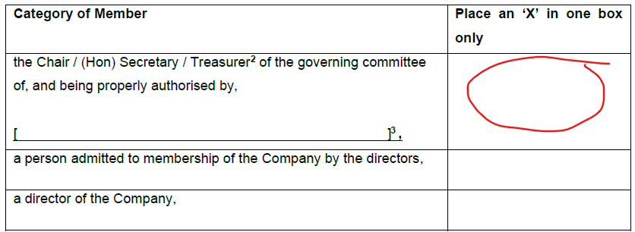 | If you are a Chair, Secretary, or treasurer (of a member club or organisation):  - Cross out the positions which aren’t applicable (from Chair, Secretary, treasurer) [2].  - In the space [3], insert name of your member club or other organisation that you are voting on behalf of.  - Your name, position and email address will be cross checked with the England Athletics portal – so please ensure that this is up to date.  - Put an ‘X’ in the box

Section of Proxy form | Additional notes
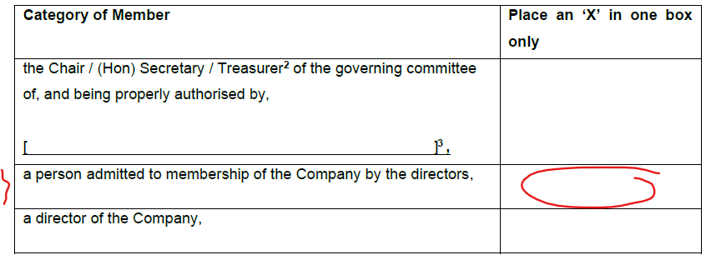 | If the Board of Directors has granted you a special membership:  - Put an ‘X’ in the box
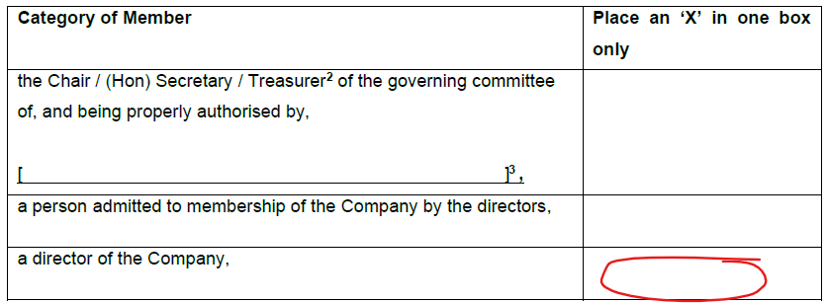 | If you are a Board Director:  - Put an ‘X’ in the box

Section of Proxy form | Additional notes
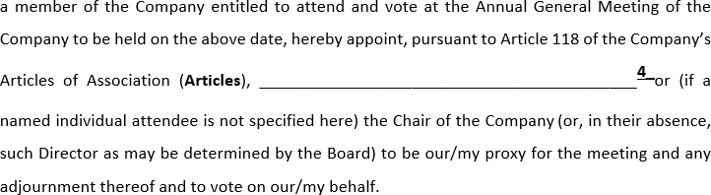 | The person listed here must be at the AGM in person to act as your proxy. Your club could arrange for someone to attend on their behalf (they do not need to be a member). Or if your club does not have anyone to attend, the Chair of England Athletics Board could act as your proxy.  In this space (4), add the name of the person that you are appointing as proxy to attend the AGM on your club’s behalf. This appointed proxy does not need to be a member. If your club doesn’t have anyone to attend the AGM, enter “The Chair” in this box (or if you leave the box blank the Chair of England Athletics Board will act as your proxy).  Whether you have a proxy attending the AGM or have stated “The Chair” or left the box blank, the Proxy form must be submitted in advance, by post or email. It must be received by 11:00am on Thursday 19th November 2026.
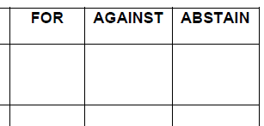 | On page 2 of the Proxy form, enter your vote for each of the resolutions.  - If you are in favour – enter an X in the ‘For’ box.  - If you are against – enter an X in the ‘against’ box.  - If you would rather not vote either way, enter an X in the ‘abstain’ box.  - If you leave boxes blank your proxy may use his or her discretion to vote on your behalf.

Once completed, post or email your Proxy form so that it is received by the Company Secretary (Muckle LLP) by 11:00am on Thursday 19th November 2026.
- By post: Muckle LLP, F.A.O. Alison Jones, Time Central, 32 Gallowgate, Newcastle upon Tyne NE1 4BF
- By email (from an authorised email address – please ensure that the club portal is up to date): as a scanned attachment showing the signature to: EnglandAthleticsAGM@muckle-llp.com

